# Tech Weeks

# Day 3 Task Sheet

**Instructions**

1. The task sheet contains the necessary resources and the assignment for the day.
2. You are given **24hrs.** to submit the assignment on the Google Classroom.
3. You must upload the **.html files** and the **screenshots of the final output on browser** you have developed, on the Google Classroom.
4. These files are to be uploaded in .zip
5. You must implement the assignment in such a way that all the requirements specified are met.
6. Read the assignment problem statement thoroughly and then start implementing it.

## Learning:

1. HTML DIVS and Span - <https://youtu.be/HLGJBWaOVh0>
2. CSS display Properties - <https://youtu.be/Qf-wVa9y9V4>
3. CSS Positioning - <https://youtu.be/jx5jmI0UlXU>
4. Google fonts implementation in HTML & CSS - <https://youtu.be/Hwq_Mr12bcI>
5. CSS Float and Clear - <https://youtu.be/LrdkRMZhgZg>
6. How to link other pages to current page? - <https://youtu.be/QEFKhE-W9T0>

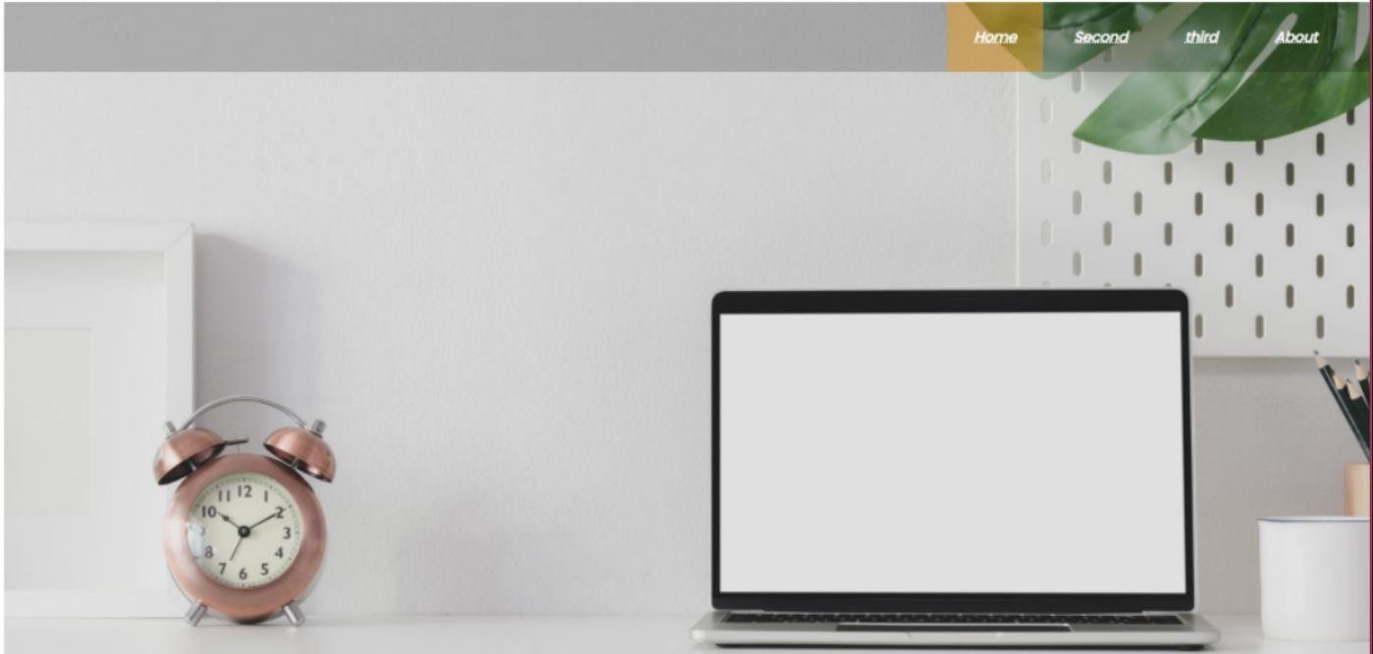

Index.html

## Today’s assignment is the continuation of yesterday’s assignment.

## Assignment:

1. Create 2 more pages second.html and about.html
2. Second.html => Add img to the body, it should cover only 60% width of the page. Background image should not repeat itself on the page.(sample images are given below)
3. About.html => About page should be created just like shown in the screen shot below. Use a custom font of your liking.
4. Link all three files, you should be able to travel from index.html to second.html or from index.html to about.html

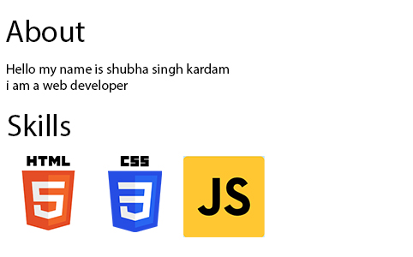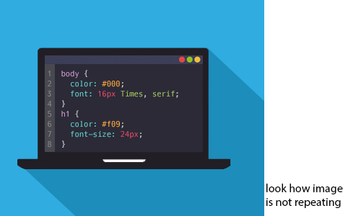Second .html

About.html